Human Resource Plan
University-Wide Print and Projection Upgrade

University of Kansas
Kansas

September 22, 2025

PRABESH RAI | Angelina gochenour | Gladis munoz marin |
heidi schieber | sirona ramahi

ITEC 380: Managing IT Projects
Professor: Jose (Joe) Ascensio

Table of Contents
Introduction ---------------------------------------------------------page 2
Org chart -------------------------------------------------------------Page 3
Roles and Responsibilities----------------------------------------Page 3-6
RACI chart------------------------------------------------------------Page 6-7
Staffing and Management--------------------------------------Page 8-9
Training, Performance review, & Rewards----------------Page 9-11
Time log--------------------------------------------------------------Page 12

Introduction
Human resources management is an important part of the Software Upgrade Project. The human resources management plan is a tool which will aid in the management of this project’s human resource activities throughout the project until closure. It is important that the right people with the right skills are working in the right area to be most productive.

For this project as all printers, scanners, multi-function devices and projectors are replaced across campus the Human Resources Management Plan is critical to maintain efficiency, meet the deadline (60 days) and minimize disruptions to the University.

This plan will be used to:
- Assign roles and responsibilities
- Find any areas that need additional resources or training
- Monitor team performance
- Make sure team actions and project goals are aligned

The purpose of the human resources management plan is to achieve project success by ensuring the appropriate human resources are acquired with the necessary skills, resources are trained if any gaps in skills are identified, team building strategies are clearly defined, and team activities are effectively managed. The HR plan also supports change management by ensuring staff are prepared for process adjustments and system updates, and that clear communication channels are maintained across all departments throughout the project. By following the Human Resource Plan, the team can stay focused and collaborative to complete the project on time and as smoothly as possible.

Org chart
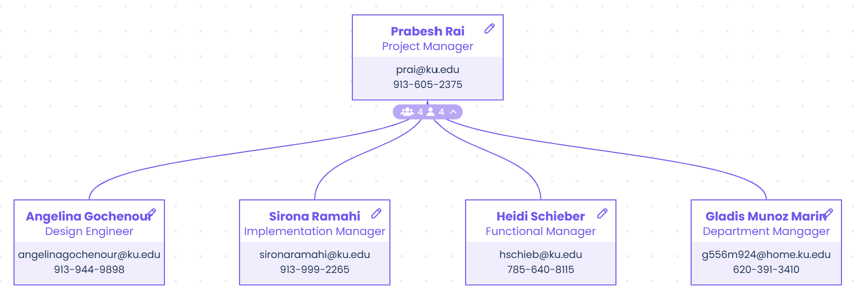

Roles and Responsibilities
Roles and responsibilities of team members and stakeholders must be clearly defined in any project. Depending on the organizational structure, project team members may represent many different groups/departments and act in the interest of different functional managers. Additionally, team members may have varying degrees of authority and responsibility. When listing roles and responsibilities the following is included:
Role – description of the portion of the project for which the member is accountable
Authority – the level at which the member may make decisions, apply project resources, or make approvals
Responsibility – the work a team member must perform to complete assigned work activities
Competency – the skill(s) required to complete assigned project activities

The roles and responsibilities for the University-Wide Print And Projection Upgrade are essential to project success. All team members must clearly understand their roles and responsibilities in order to successfully perform their portion of the project. For the University-Wide Print And Projection Upgrade the following project team roles and responsibilities have been established:

Project Manager (PM), (1 position): responsible for the overall success of the University-Wide Print And Projection Upgrade. This includes overseeing all aspects of the project, ensuring it stays within scope, budget, and timeline. The PM must authorize and approve all project related expenses and that all work meets the required quality standards, aligns with the criteria outlined in the contract, and meets acceptable performance thresholds. The PM is responsible for reporting and updating project status as stated in the communications management plan. The PM will assess the performance of all project team members and communicate their performance to functional managers. The PM is also responsible for acquiring human resources for the project by coordinating with functional managers. To succeed in this role, the PM must demonstrate strong leadership, effective communication, excellent management, and proficiency in budgeting and scheduling.

Design Engineer (DE), (1 position): responsible for gathering coding requirements for the University-Wide Print And Projection Upgrade. The DE is responsible for designing upgrades, coding, and testing the upgraded software. The DE will assist the implementation lead in the distribution and monitoring of the software upgrades throughout the network infrastructure and the hardware upgrades throughout the University. The DE must also report in a timely manner to the PM on the status of the project as expressed in the communications management plan. The DE may not authorize any project expenditures nor allocate any resources without PM approval. The DE’s performance will be managed by the PM and communicated to the Design Technology Group Manager (DE’s Functional Manager). To succeed in this role, the Development Engineer (DE) must be proficient in C#, Java, Python, and JavaScript, and have a strong understanding of printer and projection hardware.

Implementation Manager (IM), (1 position): responsible for the distribution, implementation, and monitoring of the upgrade in print and projection hardware and software. This role involves close collaboration with the DE to ensure that all components meet the institution’s security policies and compliance standards. The IM is also responsible for coordinating lack of print and projection hardware to facilitate the rollout of the new hardware and software with minimal to no disturbance of operations. Progress updates will be provided to the Project Manager (PM) as outlined in the project’s communications management plan. The IM’s performance will be assessed by the PM and communicated to the IM’s functional manager (Network Manager). To succeed in this role, the Implementation Manger (IM) must be proficient in both print and projection systems, including hardware and software management.

Functional Manager (FM), (1 position): responsible for providing resources for the project in accordance with the project staffing plan. The FM is responsible for working with the PM to determine skill sets required and approve resource assignments. The FM must also review the performance of assigned team members, using the PM’s feedback regarding project performance.

Department Manager (DM), (1 position): responsible for overseeing departmental readiness and resource allocation for the successful implementation of the print and projection hardware and software upgrade. The role requires close coordination with the Project Manager (PM) and other stakeholders to ensure that departmental operations remain aligned with project timelines and institutional goals. The DM supports communication between project teams and department staff, helping to address any challenges that may impact rollout capabilities. Regular status reports and department level updates will be provided to the PM in accordance with the project’s communications management plan. The DM’s performance will be evaluated based on department contributions to the project and shared with the DM’s functional manager. To succeed in this role, the Department Manager (DM) must demonstrate strong leadership, organizational, and communication skills, along with a clear understanding of departmental
operations and institutional policies.

Project Organizational Charts
The purpose of this RACI chart is to illustrate the responsibilities of team members as they relate to the project tasks. Tools such as responsible, accountable, consult, inform (RACI) are classified. Additionally, resource breakdown structures are used to show how responsibilities are assigned by department or by type of resource respectively.
Any proposed changes to project responsibilities must be reviewed and approved by the project manager. Changes will be proposed in accordance with the project’s change control process. As changes are made all project documents will be updated and redistributed accordingly.

 | Project Manager | Design Engineers | Implementation Manager | Training Leads | Functional Managers | Department Managers
Requirements Gathering | A | R | R | C | C | I
Coding Design | A | R | C |  | C | I
Coding Input | A | R
Software Testing | A | R | C |  | I | I
Network Preparation | A | C | R |  | I | I
Implementation | A | C | R | C | C | C
Conduct Training | A |  |  | R | C | C

Key:
R – Responsible for completing the work
A – Accountable for ensuring task completion/sign off
C – Consulted before any decisions are made
I – Informed of when an action/decision has been made

Staffing Management
This section contains information on several areas including: when and how human resource requirements will be acquired, the timeline for when resources are needed and may be released, training for any resources with identified gaps in skills required, how performance reviews will be performed, and the rewards and recognition system to be used. It is important to note that depending on the scope of the project there may be other items included in staffing management (government and/or regulatory compliance, organizational health, and safety, etc). Our goal is to ensure that each team member is properly supported throughout the project lifecycle so the team can remain motivated and aligned with project goals.

Staff Acquisition:
For the Software Upgrade Project, the project staff will consist entirely of internal resources. There will be no outsourcing/contracting performed within the scope of this project. The Project Manager will negotiate with functional and department managers in order to identify and assign resources in accordance with the project organizational structure. All resources must be approved by the appropriate functional/department manager before the resource may begin any project work. The project team will not be co-located for this project and all resources will remain in their current workspace. Since resources are not co-located, coordination will occur through virtual collaboration tools such as Microsoft Teams, project management dashboards, and shared documentation.

Resource Calendars:
The Software Upgrade Project will last for five weeks. All resources are required before the project can begin. The resource histogram below illustrates that design engineers are required to perform 40 hours per week per engineer for the first three weeks of the project. Their requirements are then scaled back to 5 hours per engineer in the fourth week. After the fourth week the design engineers will be released from the project. The implementation manager will also be released from the project after week 4. The training lead will be required to perform 15 hours of work in the first week and a full 40 hours of training during week 5.

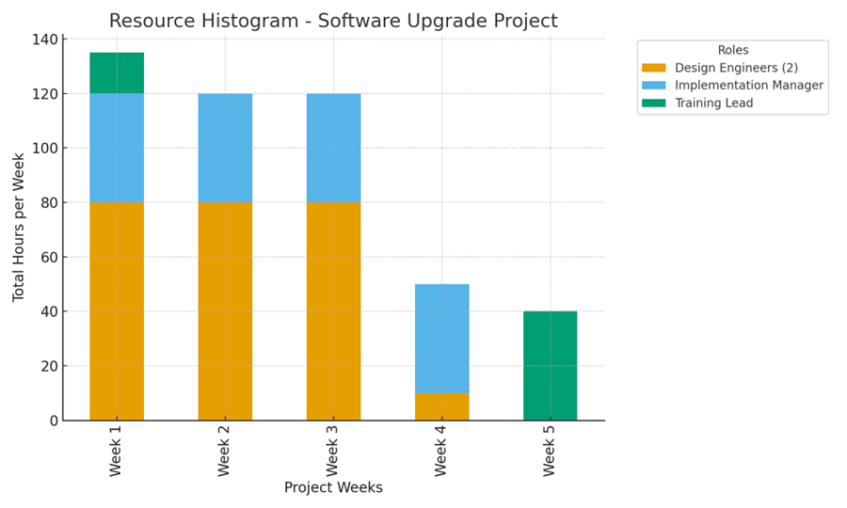

Training and Development:
We will use our Scope deliverables guide to create a training plan for students and staff members on the upgraded system. We will also create guidelines for each system's usage. For the development phase we already have adequate staff members with the required skills, and we will use funding from the project reserve if we need to include additional resources for training and development. The training and development will focus on the following key points:
- Upgraded system: Everyone affected by the project changes will be trained in the new features and functionalities of the upgraded print and projection system. This will include hands-on practice with the new hardware and software for faculty, staff, and students.
- Creating guides and notes: Training will also cover the process of creating and documenting user guides and internal notes. This will ensure that knowledge is captured and shared for future reference.
- Support Channels: Clear instructions for how to request technical support during the transition.

Performance Reviews:
The project manager will handle project management by clearly communicating roles and assignments at the beginning of the project, ensuring all team members understand their specific responsibilities and the project schedule. He will then provide performance review feedback continuously throughout the project through weekly team meetings and one -on-one sessions. He will also evaluate each team member’s performance based on the effectiveness and timeline of their assigned tasks. This will allow the team to make adjustments and improvements as the project progresses. Finally, partnering with the functional manager and analyzing the performance summary, they will conduct a formal performance review before releasing the project related resources.

Recognition and Rewards:
Currently our project scope does not provide a direct method of rewards but, there are several planned recognition and reward items for project team members upon successful completion of the project, and we may add a few more as the project progresses. The ones that have been discussed are:
- Celebration party: A party will be held to celebrate the team’s success, with their families present.
- CEO certificate of thanks: Every team member who participated in the project will receive a certificate of thanks from the CEO.
- Company Newsletter feature: All project participants will be featured as role models in the company newsletter.
- Gift Hampers: During each project milestone, participating team members (excluding leadership) will receive various rewards through a lucky draw system.

Time Log:
